**Queries to Practice**

1. Find all products that are not in the 'Electronics' category.

**Query:**

db.products.find({category:{$ne:"Electronics"}})

**Output:**

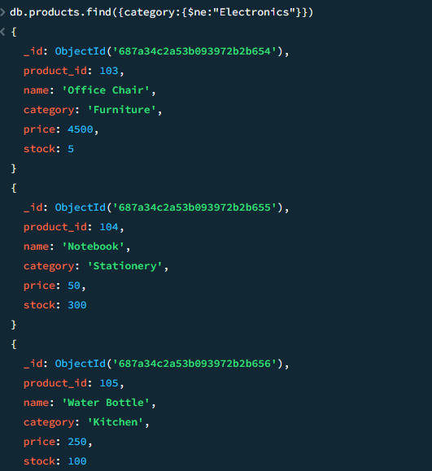

2. Get all products where price is greater than 1,000.

**Query:**

db.products.find({price:{$gt:1000}})

**Output:**

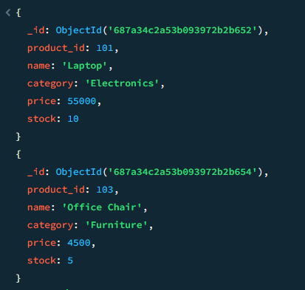

3. Find products that have stock less than 50.

**Query:**

db.products.find({stock:{$lt:50}})

**Output:**

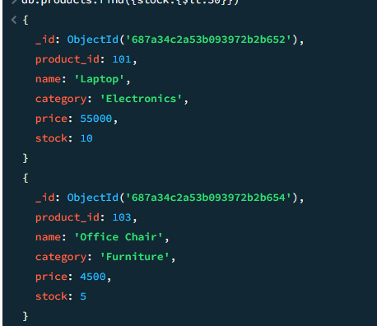

4. List products whose category is either 'Furniture' or 'Kitchen'.

**Query:**

db.products.find({ category: { $in: ["Furniture", "Kitchen"] } })

**Output:**

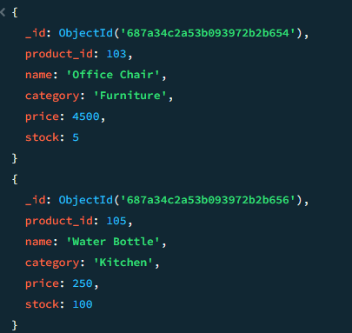

5. Get products with stock between 10 and 100.

**Query:**

db.products.find({ stock: { $gte: 10, $lte: 100 } })

**Output:**

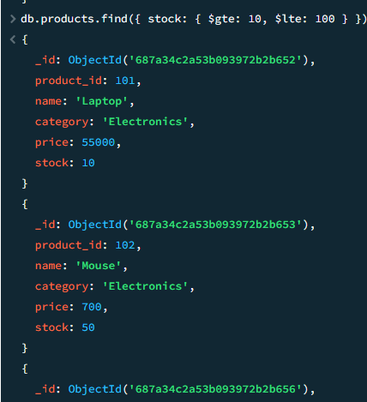

6. Find all products where price is not 700.

**Query:**

db.products.find({ price: { $ne: 700 } })

**Output:**

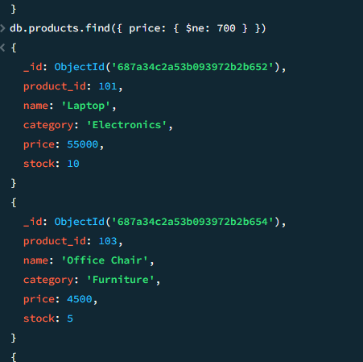

7. Display all products whose name starts with 'N'.

**Query:**

db.products.find({ name: { $regex: "^N" } })

**Output:**

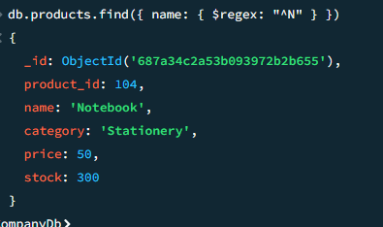

8. Find all products whose stock is not more than 5.

**Query:**

db.products.find({ stock: { $lte: 5 } })

**Output:**

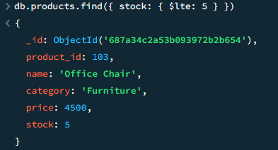

9. List products with category not in ['Stationery', 'Kitchen'].

**Query:**

db.products.find({ category: { $nin: ["Stationery", "Kitchen"] } })

**Output:**

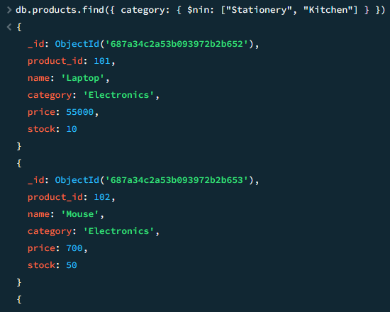

10. Find one product not in the 'Furniture' cate

**Query:**

db.products.findOne({ category: { $ne: "Furniture" } })

**Output:**

